**Track Target Companies Project**

**Description:**

The project “Track Target Companies” is created to demonstrate the usage of modern javascript framerwork (Angular 7) and perform CRUD (Create, Read, Update, Delete) operations on the data of Target Companies for Acquisition.

**Technologies Used:**

1. Angular 7
2. Bootstrap 4
3. angular-in-memory-web-api (For Mocking data)

**Steps to Run the application :**

1. Open the source folder in VS Code or Eclipse 🡪 Go to Terminal window 🡪Type “ng build” then 🡪 “ng serve”

(OR)

1. Open Command prompt, navigate to root folder path of the project and run “ng serve” command.
2. Now open any browser and enter <http://localhost:4200/> to see the Website.

**Screenshots Below**

**Screenshots:**

1. Home Page/List of Target Companies:

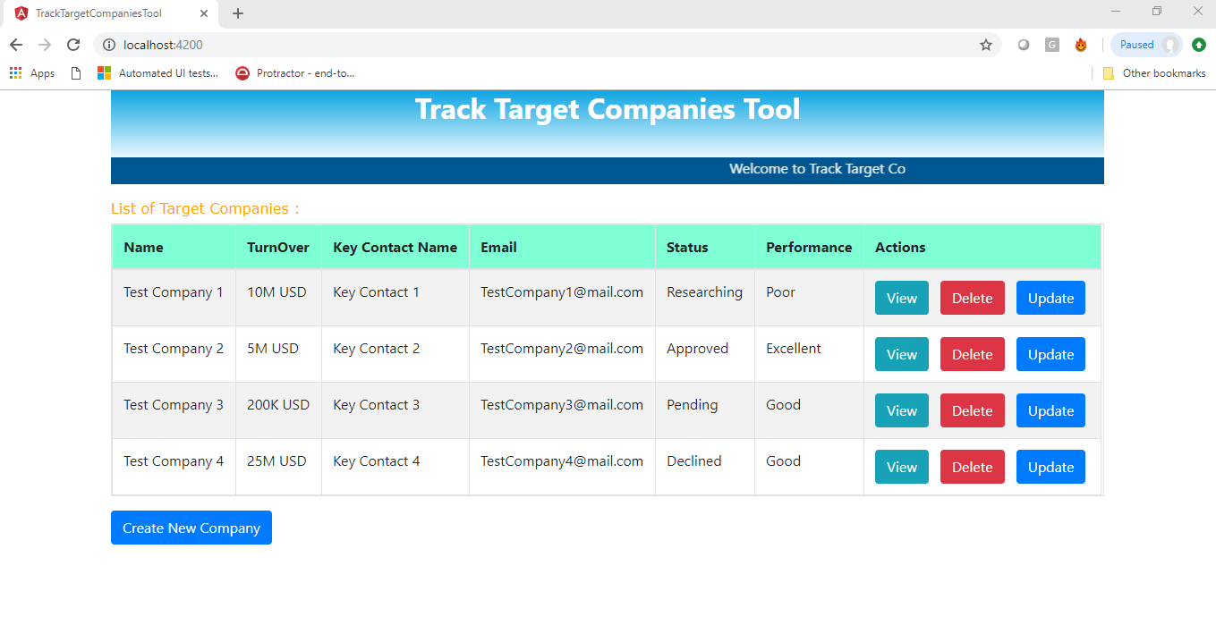

1. Create New Target Company Page

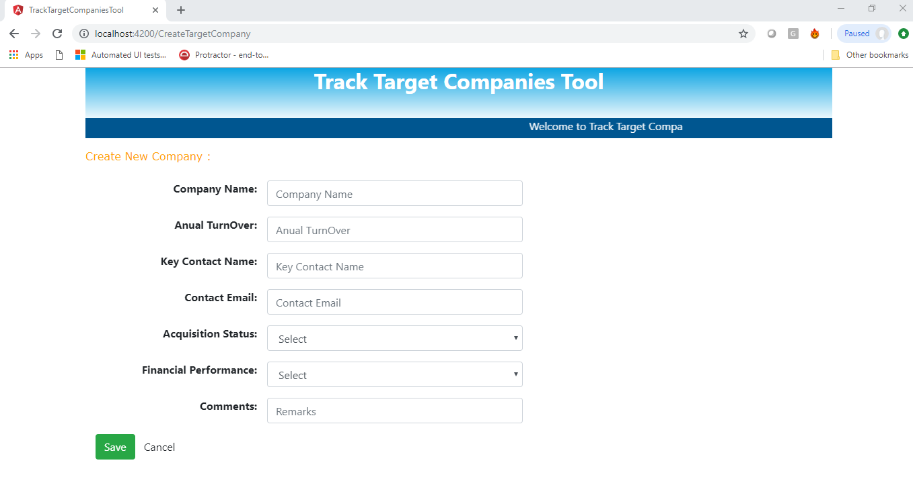

1. View Target Company Page:

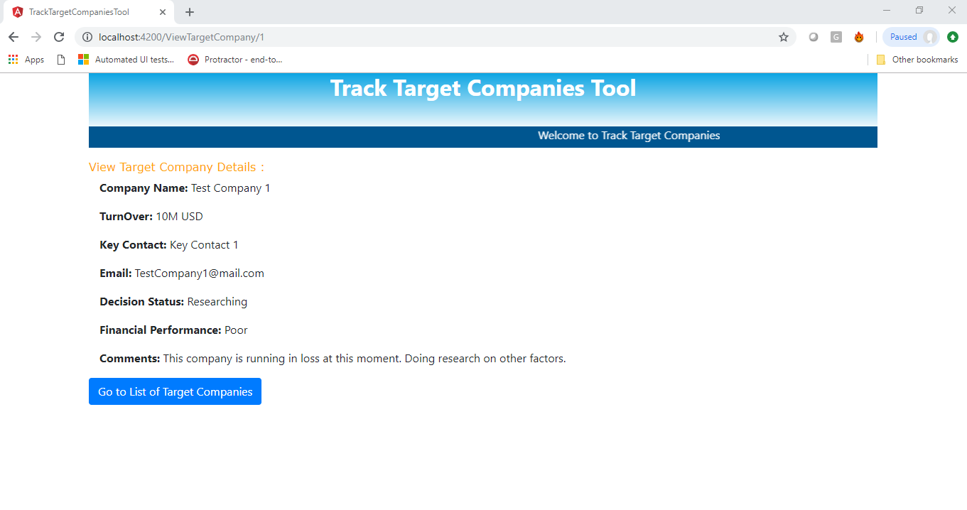

1. Edit Target Company Page:

